Lab 2

# Task

Write a function ‘min’ that takes two arguments and returns their minimum.

# Task:

Write a loop that takes an input ‘height’ and prints a pyramid of hashes with that height to the console.

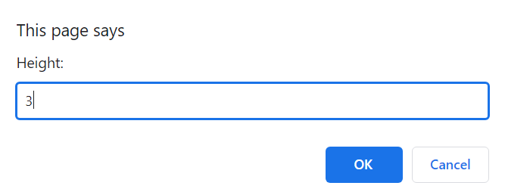



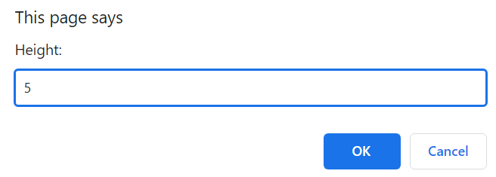

# 

# Task 1

Write a function named ‘countBs’ that takes a string as it’s only argument and returns number of uppercase ‘B’ characters in that string.

# Task 2

Write a function called ‘countChar’ that behaves like ‘countBs’, except it takes two arguments: a string and a letter that is to be counted in the string.

Next, rewrite ‘countBs’ to make use of this new function